Certificate of Registration

EFR Certification hereby certify that
PURE INTEGRITY SDN. BHD.
No. 139, Jalan S2 B6, Seremban 2, 70300 Seremban, Negeri Sembilan, Malaysia



Has been assessed against the requirements of:
ISO 9001:2015
“Quality Management Systems”

And is registered for the following scope of activities:
Provision of technical service and training in process safety, asset integrity, and reliability of O&G industry and other relevant industrial sectors.



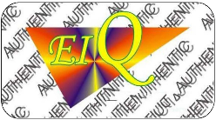
Scan QR for Certificate Validity Verification
“This is an accredited certificate authorised for issued by Accreditation Service for Certifying Bodies (Europe) Limited in accordance with ISO/IEC 17021:2015
"Conformity assessment - requirements for bodies providing audit and certification of management systems".
This certificate is only valid if confirmed against the QRverification and current listing of certificate holders in www.irqao.com
Used of this certificate, accreditation and certification logo are subject to terms and conditions.
Q Sentral, Level 35-02 (East Wing), 2A, Jalan Stesen Sentral 2, KL Sentral, Kuala Lumpur 50470, Malaysia.
Web site: www.efrcert.com Email: enquiries@efrcertification.com
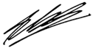
Dr. Edly Ferdin Ramly
Certification Director
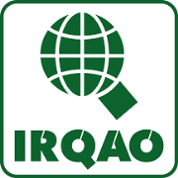

Registration No : 000539M01
Initial Certificate : 13 Oct 2026
Issuance Date : 22 Oct 2026
NACE rev02 : 71.12
Valid to : 12 Oct 2029

